Specification of 500/800 rewinding machine

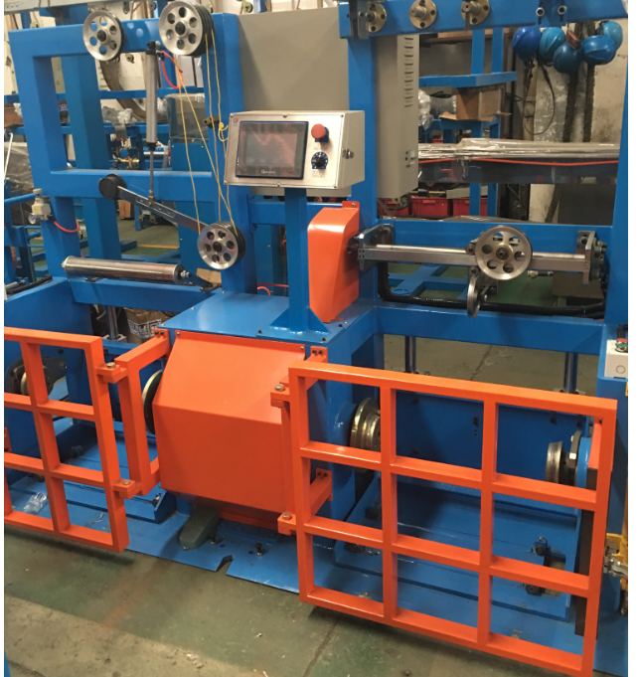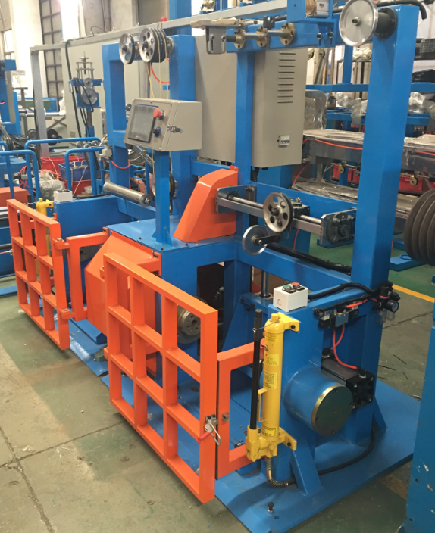
1. Main parameter:
1.1 | Model No.: | 500/800mm
1.2 | Suitable material | Copper wire、Aluminum wire、Insulation wire
1.3 | Max diameter of wire | Copper wire: 3.0mm  Aluminum wire: 4.0mm  Insulation cable : 1.0-6.0mm²
1.4 | Suitable bobbin size | 500/800mm
1.5 | Max loading | 600kg
1.6 | Rewinding speed | 0-250 m/min
2. The main components:
2.1 | 500/800mm pay off with motor driving | 1 set
2.2 | Wire guider | 1 set
2.5 | 500/800mm take up and transverse | 1 set
3. Detailed technical description:
3.1 500/800mm pay off with motor driving
3.1.1 | Bobbin size | 500-800mm
3.1.2 | Max speed | 250 m/min
3.1.3 | Speed control | Automatically control by dancer
3.1.4 | Loading/unloading | Manual hydraulic
3.1.5 | Clamping/releasing | Pneumatic
3.1.6 | Motor | 4KW AC motor
3.1.7 | Motor control | Inventor control
3.1.8 | Brake | Pneumatic brake
Detail Specification
Motorize cable-sending unit is available, machine completed with bobbin driven system.
Application: for cable pay off in the process of cable manufacturing or rewinding.
Shaft-less type, open and close of arms is done by handle screws manually.
A slip type torque limit to be fitted on each driven unit to getting a just locking tension on the bobbin.
Safety control:
Bobbin lifting up and down limit positions control protection.
Bobbin close and open limit positions control protection.
3.2. 500/800mm take up and transverse
3.2.1 | Bobbin size | 500-800mm
3.2.2 | Max speed | 250m/min
3.2.3 | Loading/unloading | Manual hydraulic
3.2.4 | Clamping/releasing | Pneumatic
3.2.5 | Motor | 4KW AC motor
3.2.6 | Motor control | Inventor control
3.2.7 | Traverse | Polished rod traversing
3.2.8 | Meter counter | Digital type
Detail Specification
Application: for cable pay off in the process of cable manufacturing or rewinding.
A slip type torque limit to be fitted on each driven unit to getting a just locking tension on the bobbin.
Safety control:
Bobbin lifting up and down limit positions control protection.
Bobbin close and open limit positions control protection.
4. Electrical control system
4.1 | Main low-voltage components : Schneider brand
4.2 | Main motor AC motor: SIEMENS brand
4.3 | AC driver system: SIEMENS brand
4.4. | Touch panel: SIEMENS brand
4.5. | PLC: SIEMENS brand
5. Drawing
5.1 | Machine layout, foundation drawing
5.2 | Electricity, piping drawings
5.3 | Operation manual
5.4 | The principle drawing of the electrical system
5.5 | The list of the cable.
6. Other
6.1 | The operation direction of the machine: right hand or based on the customer’s requires.
6.2 | Machine color: according to the color plate offered by customers.
6.3 | The bobbin: according to the drawing offered by customers.

SHANGHAI SHINEWORLD ENGINEERING CO., LTD.

2020.12.29

