Specification of 2500 rewinding machine
1. Main parameter:
1.1 | Model No.: | 1250/2500mm
1.2 | Max diameter of cable | Φ120mm
1.3 | Suitable bobbin size | 1250/2500mm
1.4 | Rewinding speed | 40.0m/min
2. The main components:
2.1 | 1250/2500mm portal type pay off | 1 set
2.2 | Wire guider | 2 sets
2.3 | Spark tester | 1 set
2.4 | Meter counter | 1 set
2.5 | 1600kg caterpillar | 1 set
2.6 | 1250/2500mm portal type take up and transverse | 1 set
2.7 | Electric control system | 1 set
3. Detailed technical description:
3.1 1250/2500mm Portal type pay off
3.1.1 | Bobbin size | 1250-2500mm
3.1.2 | Max speed | 80 m/min
3.1.3 | Max diameter of cable | Φ120mm
3.1.4 | Traversing motor | 1.1 kw AC motor + cycloid gear reducer
3.1.5 | Lifting motor | 1.5 kw AC motor + cycloid gear reducer
3.1.6 | Clamping motor | 1.1 kw AC motor+ cycloid gear reducer
3.1.7 | Portal ground rail running type, upper casing type structure, portal frame is made by bending welding; The two centers of the wire coil are lifted and lifted by two motors via cycloidal reducer. Each center seat can be lifted and lowered separately or simultaneously. The wire disc clamps through the motor - deceleration, and is equipped with clamping overload protection. When the wire rack moves left and right, its command is controlled by the signal sent by the centralizer located at the front of the wire rack, which can ensure that the cable is always pay-off at the center.
3.18 | Pay-off tension: mechanical caliper structure, the releasing tension can be adjusted manually.
 | 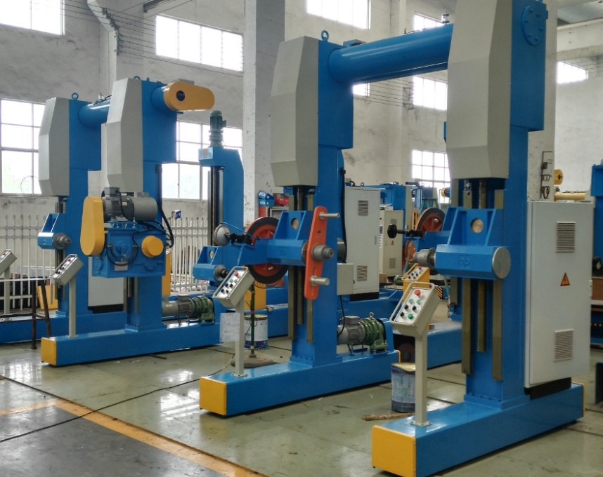

3.2 Spark tester
3.2.1 | Dia. range: | ~Φ120mm;
3.2.2 | Voltage: | 0~30KV;
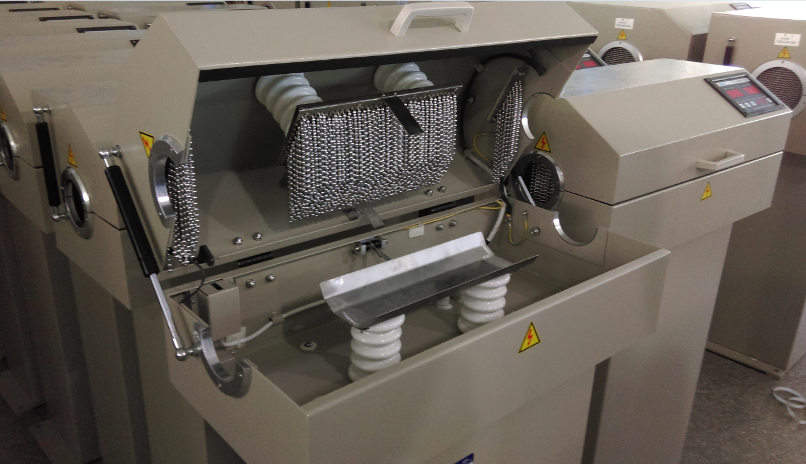

  - Meter Counter 1set
3.2.1 | Wheel type.
3.3.2 | Applied cable diameter: | ~Φ120mm;
3.3.3 | Max. counting length | 9999m
3.3.4 | Counting accuracy | ≤0.4%
3.3.5 | Double wheels, one of wheel is active, vertical mounting, the compacted wheels has damping spring, there are guiding rollers at entry and outlet.
3.3.6 | With electronical and mechanical meter counting function.
3.3.7 | 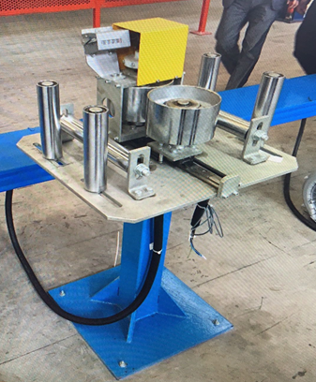
3.4 1600kg belt type pneumatic caterpillar
3.4.1 | Max force | 1600kg
3.4.2 | Max speed | 40m/min
3.4.3 | Cable size | Φ15～Φ120mm
3.4.4 | Qty of cylinders | 6 pairs
3.4.5 | Working length | 1900mm
3.4.6 | Width of caterpillar belt | 120mm
3.4.7 | Driving motor | 7.5KW SIEMENS motor
3.4.8 | Motor control | SIEMSNS
3.4.9 | Transmission | Motor with gearbox reducer
3.4.10 | Total pressure | 7.3 kg (6 BAR)
3.4.11 | Top bottom flat belt haul off, compression and tensioning by air actuation.
3.4.12 | Entrance and exit equips with wire guide rollers.
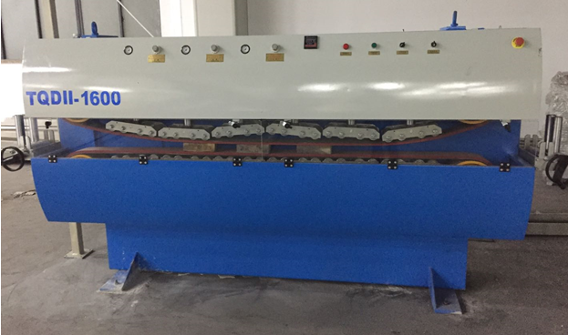
3.5 1250/2500mm Portal type take up
3.4.1 | Take-up bobbin | PN1250mm~PN2600mm
3.4.2 | Max. loading capacity | 12T
3.4.3 | Max. traversing diameter | Φ120mm
3.4.4 | Max. take-up speed | 45m/min
3.4.7 | Take-up motor | 7.5 kw (AC)
 | Traversing motor | 1.1 kw (AC) + cycloid gear reducer
 | Lifting motor | 1.5 kw (AC) + cycloid gear reducer
 | Clamping motor | 1.1kw (AC) + cycloid gear reducer
3.4.11 | Take up motor is AC inverter motor, controlled by frequency inverter. Take up tension is stable and adjustable.  Portal type ground rail walking structure. electric lift, electric clamp or loosen bobbins.
3.4.12 | Portal frame moves for traversing, driven by AC inverter motor, controlled by frequency inverter. Traversing speed follows up winding speed. Traversing pitch is step-less adjustable.
 | 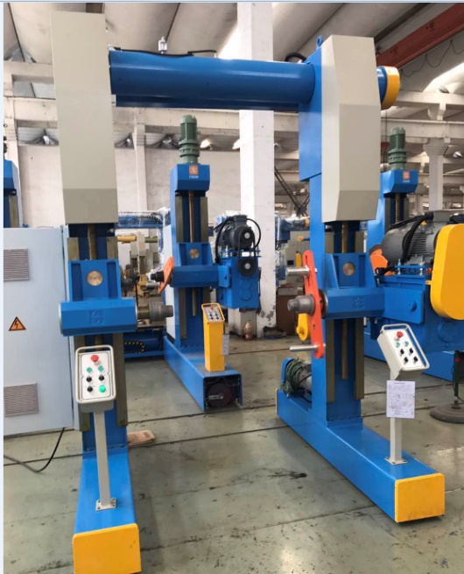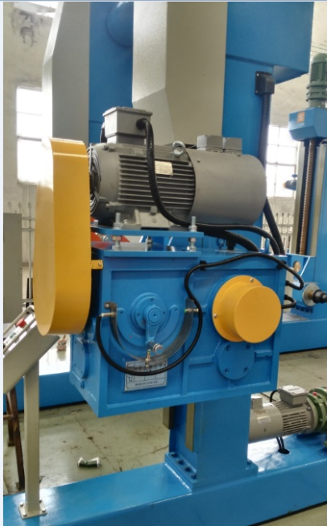
4. Electrical control system
4.1 | Main low-voltage components : Schneider brand
4.2 | Main motor AC motor: SIEMENS brand
4.3 | AC driver system: SIEMENS brand
4.4. | Touch panel: SIEMENS brand
4.5. | PLC: SIEMENS brand
5. Drawing
5.1 | Machine layout, foundation drawing
5.2 | Electricity, piping drawings
5.3 | Operation manual
5.4 | The principle drawing of the electrical system
5.5 | The list of the cable.
6. Other
6.1 | The operation direction of the machine: right hand or based on the customer’s requires.
6.2 | Machine color: according to the color plate offered by customers.
6.3 | The bobbin: according to the drawing offered by customers.

SHANGHAI SHINEWORLD ENGINEERING CO., LTD.

2020.12.29

