SW-800/630 Rewinding Machine
1. Application
1.1 The rewinding line will be mainly used for Galvanized Steel Round Wire and Galvanized Steel Flat Wire. But will be used to rewind conductor as well.
1.2 For Round Wire, rewind from Coil to Reel 630. It will be 2 coils of steel wire rewinded simultaneously into 1 reel.
1.3 For Flat Wire, rewind from reel 800mm to reel 630mm.
2. Main technical parameter
2.1 | Steel round wire size | Φ0.80～Φ2.0mm
2.2 | Flat steel wire | 0.8x4.0mm
2.2 | Pay off bobbin size | 630/800mm
2.3 | Take up bobbin size | 500/630mm
2.4 | Take up motor | 5.5KW AC VF motor
3. Main components
3.1 | Basket pay off for steel wire coil | 1 set
3.2. | 630/800 pay off | 1 set
3.3 | Straightening device | 1 set
3.4 | Meter counter | 1 set
3.5 | 500/630 take up | 1 set
3.6 | Electrical control system | 1 set
4. Specification for the main components
4.1. Basket pay off for steel wire coil
4.1.1 | Size | Max OD:1100 according to customer steel wire coil
4.1.2 | Tension | Pneumatic control
4.1.3. | Structure | As the drawing from customer
4.1.4 | Working type | - pay off rating and steel wire from top side  - pay off rating and steel wire from front side  It can cover all type steel wire coil.  With back twist turn pulley for coil type payoff when we release from top.
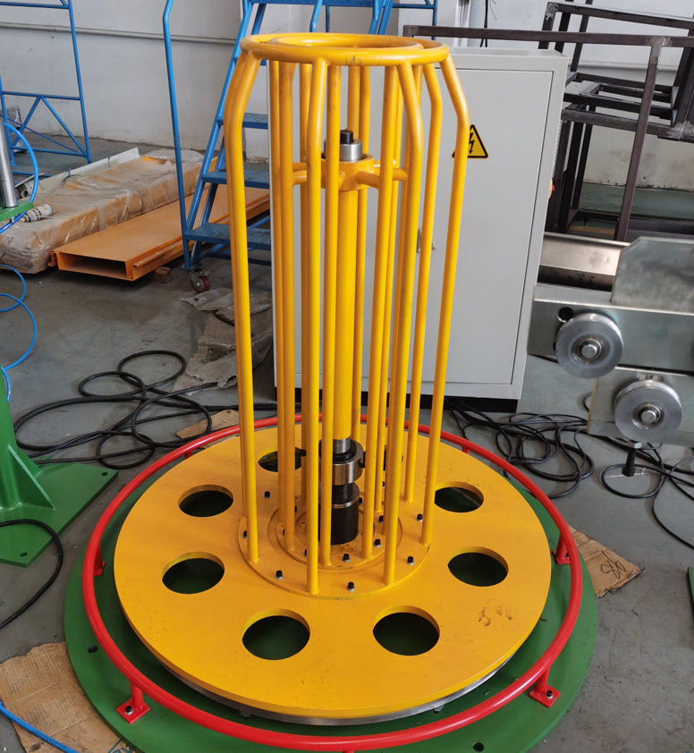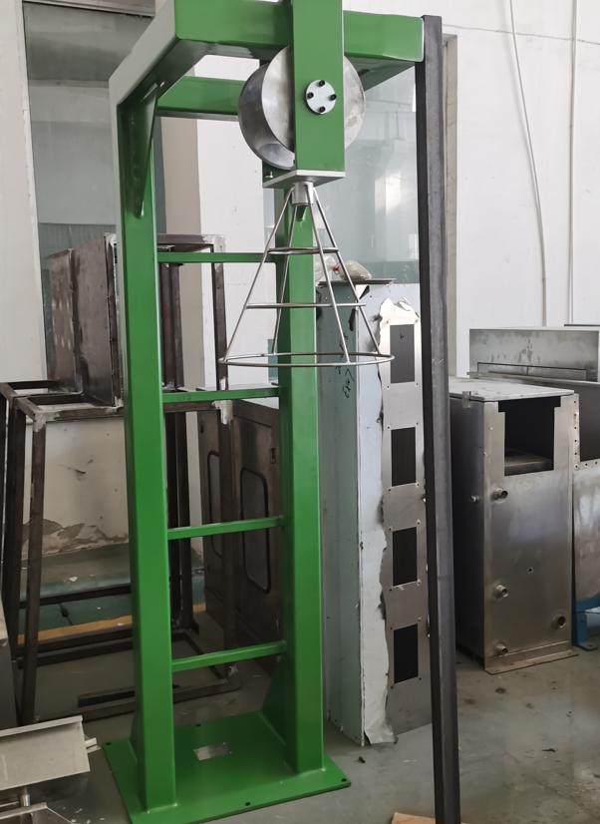

4.2. 630/800mm box type motorized pay off without shaft
4.2.1 | Bobbin size | 630/800mm
4.2.2 | Max. loading | 800kg
4.2.3 | Design speed | 60-250m/min
4.2.4 | Driving motor | 5.5KW AC VF motor
4.2.5 | Bore size | 80/127mm(according to customer drawing)
4.2.6 | Clamping | Pneumatic clamping
4.2.7 | Loading/unloading | Motor driving, safe and quick, pneumatic clamping position setting
4.2.8 | Brake | pneumatic brake
4.2.9 | Tension control: | it tracks tension control automatically.  It can achieve constant tension through the feedback signal sent by pneumatic tension shelf when pay off t to avoid core wire or copper wire deform when the wire is pulled.
4.2.10 | Pneumatic | Taiwan AIRTAC
4.2.11 | Motor brand | Siemens brand
4.2.12 | Inverter brand | Siemens brand
4.2.13 | Low voltage  component | Schneider
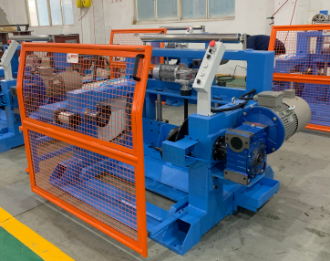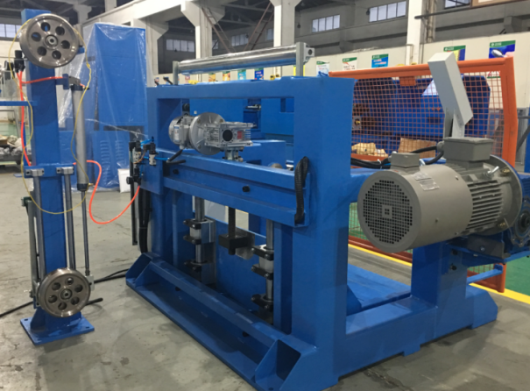
4.3. Straightening device
4.3.1 | Form | X-Y direction strengthening device
4.3.2 | Wire size | Max.3.5mm-steel wire
4.3.3 | Guide wheel size | 30mm Alloy wheel with ceramic coating
4.3.4 | guide wheels | 5 PCS in each group for one direction  10 PCS in total
4.3.5 | Two sets of straighteners, straightening the conductor X and Y direction , front and back respectively.
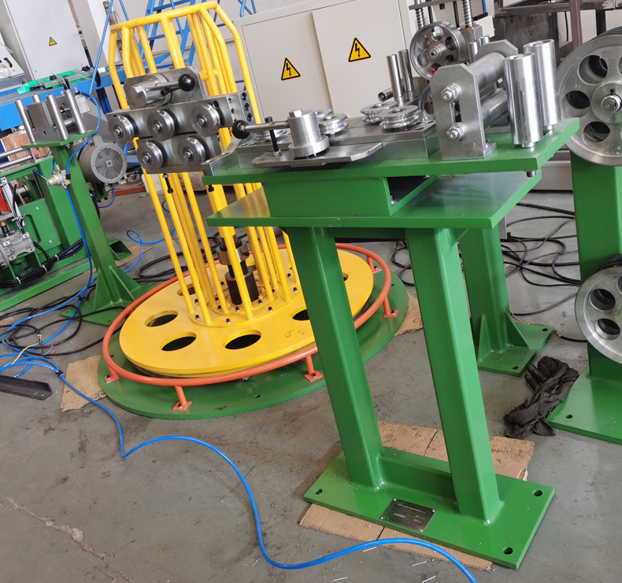
4.4 Mechanical & Electrical Meter Counter
4.4.1 | Form | one-way only
4.4.2 | Control | Electronic digital display
4.4.3 | With mechanical and electrical meter countering function
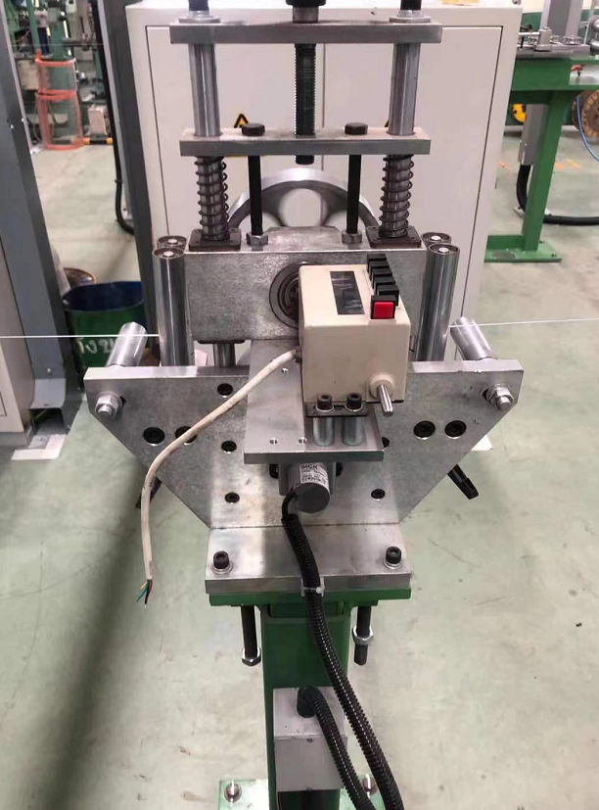
4.4. 500/630 take up
4.4.1 | Bobbin size | 500/630mm
4.4.2 | Max. loading | 500kg
4.4.3 | Design speed | Max.250m/min
4.4.4 | Driving motor | 5.5KW AC VF motor
4.4.5 | traverse | 400W AC Servo motor driving control with MITSUBISH brand servo controller
4.4.6 | Pintle size | 127mm (and according to customer drawing)  Please send us the drawing of bobbin from 500-630mm
4.4.7 | Clamping | Pneumatic clamping
4.48 | Loading/unloading | Motor driving, safe and quick, pneumatic clamping position setting
4.4.9 | Brake | pneumatic brake
4.4.10 | Tension control | it tracks tension control automatically.  It can achieve constant tension through the feedback signal sent by pneumatic tension shelf when pay off to avoid core wire or copper wire deform when the wire is pulled.
4.4.11 | Pneumatic | Taiwan AIRTAC
4.4.12 | Motor brand | Siemens Brand
4.4.13 | Inverter brand | Siemens Brand
4.4.14 | Low voltage component | Schneider Brand
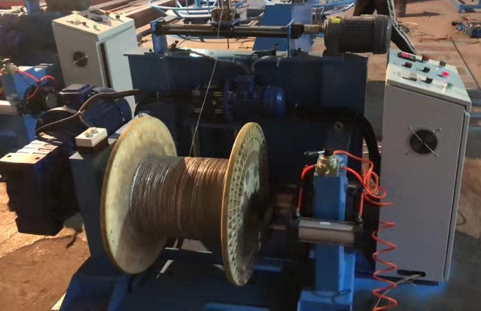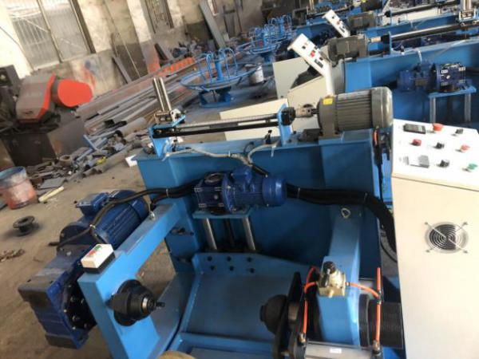
4.5 Electrical transmission and control system
4.5.1 | Power supply: | 3-phase,-4-wires,-380V(±10%), 50HZ
4.5.2 | The protection of this machine is as follows:
4.5.3 | Overloading protection of take-up with traversing, power protection
4.5.4 | Pressure protection
5. The brand Electrical control system
5.1 | Main AC motor: SIEMENS brand
5.2 | AC converter: SIEMENS brand
5.3 | Main low-voltage components : Schneider brand
5.4 | PLC: SIEMENS S7-1200 series.
5.5 | SIEMENS HMI.
6. Drawing
6.1 | Machine layout, foundation drawing
6.2 | Transmission system drawing.
6.3 | Electrical principle and piping drawings
6.4 | Operation manuals
7. Other
7.1 | The operation direction of the machine: right hand or based on the customer’s requires.
7.2 | Machine color: according to the color plate offered by customers.
7.3 | The bobbin: according to the drawing offered by customers.
7.4 | Bearing: NSK brand.
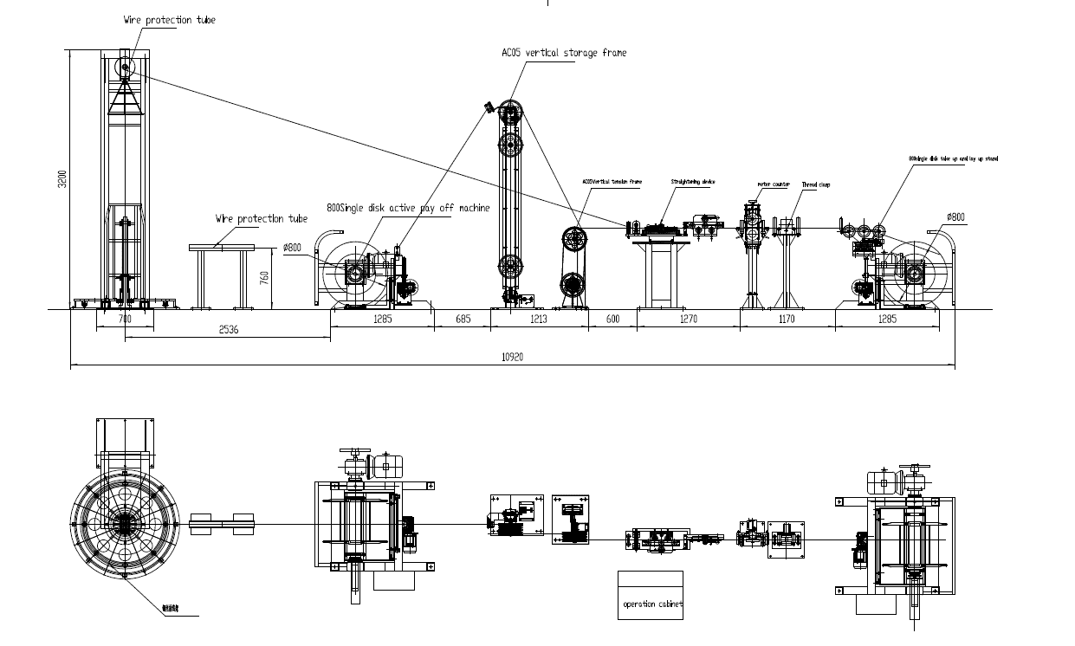
Layout for reference

SHANGHAI SINEWORLD ENGINEERING CO., LTD.
2022.04.14

